**SOP of Ajit Bakery**

**Step 1.** Enter **Username** and **Password** to Login.

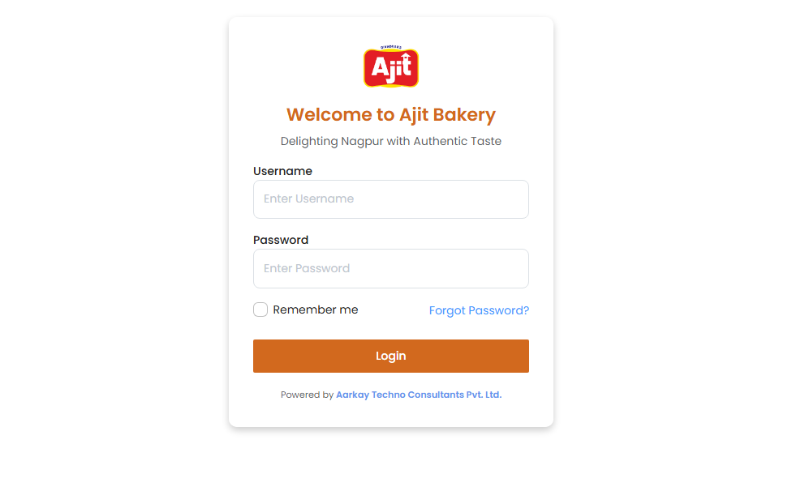

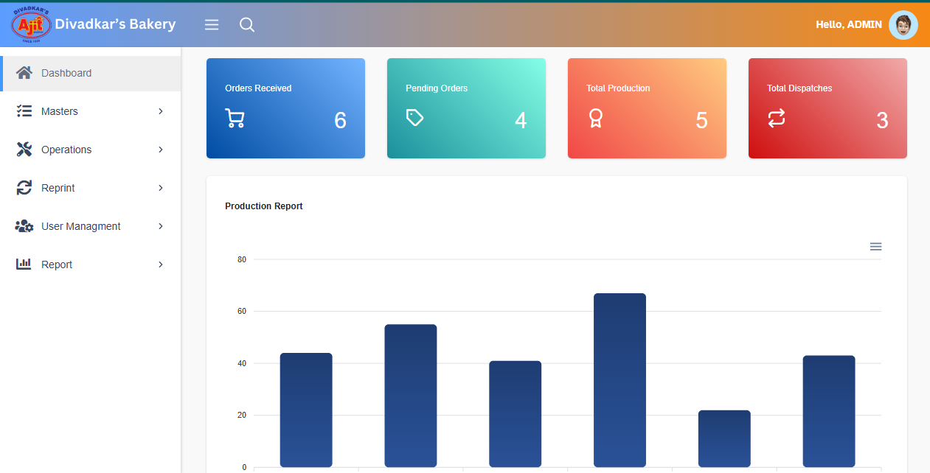

**Step 2.**  Click on **Masters** and **Product Master**.

**1.** Click on Add.

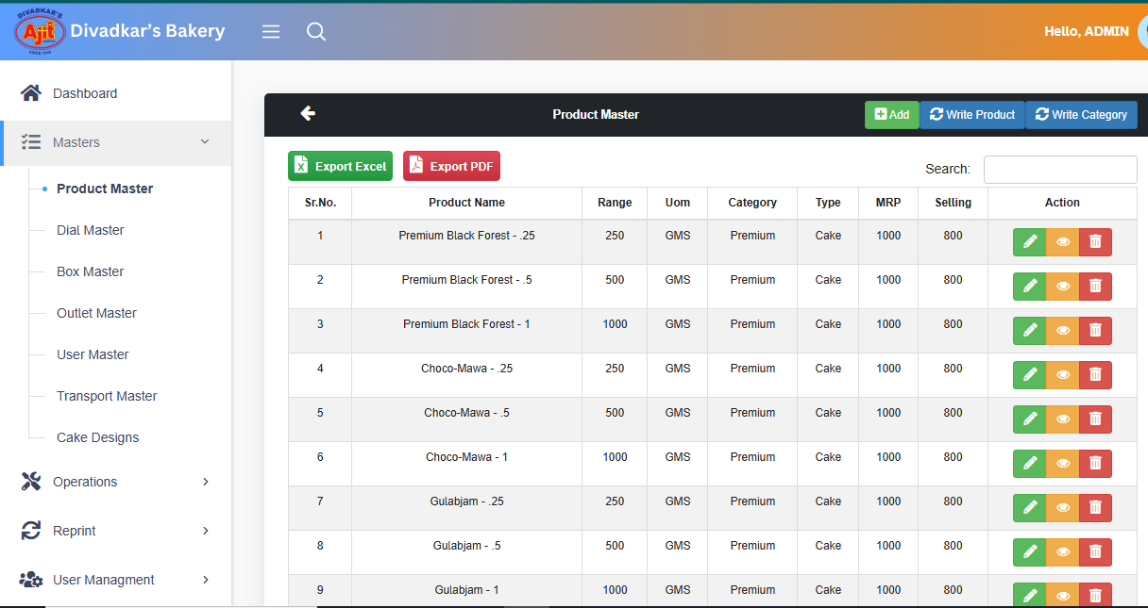

1. Enter Production Name,Quantity, Unit Quantity (Gms)
2. Select Uom.
3. Enter MRP, Sale Rate
4. Select Dial codes, Category and Type from dropdown
5. Select Product Height and Height UOM from the dropdown.

Click on Save.

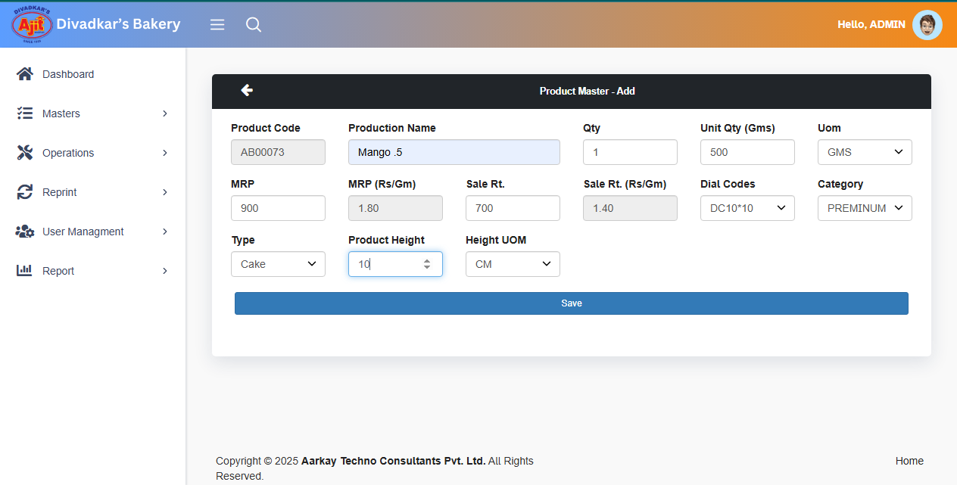

**2.** Click on Edit.

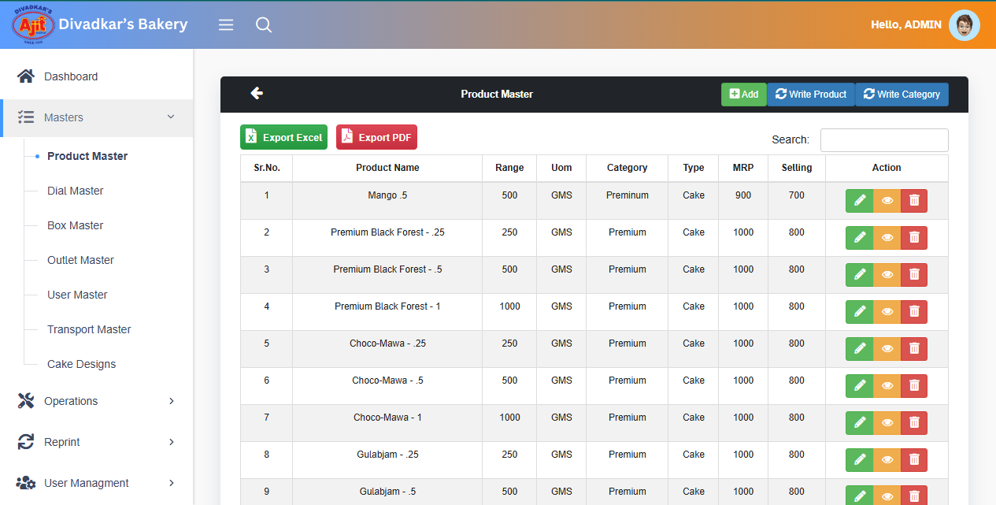

1. Enter Product Name.
2. Quantity, Unit Quantity (Gms).
3. Select Uom.
4. Enter MRP and Sale Rate.
5. Select Dial Codes, Category and Types from the dropdown.

Click on Edit.

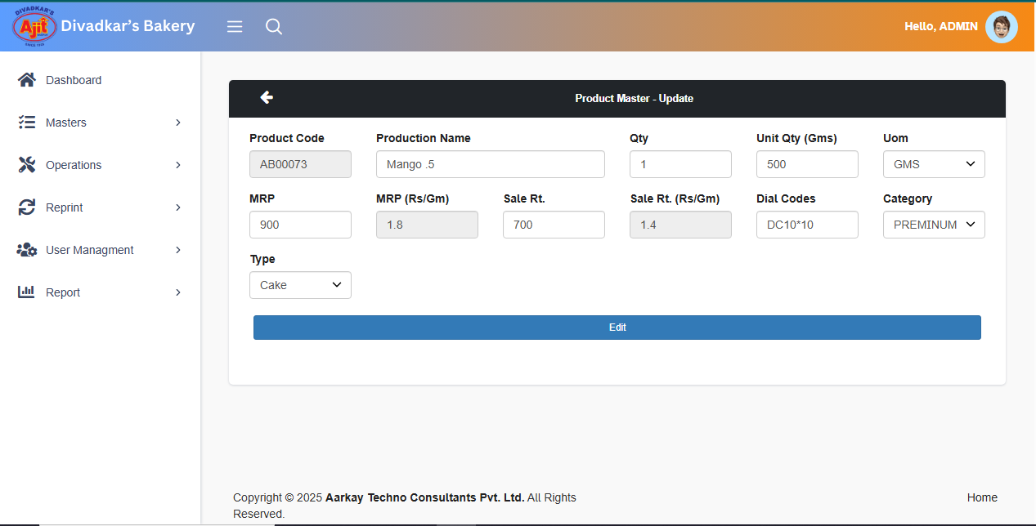

**3.** Delete.

If you click on Delete you get the message “**Are You Sure**” then click on “Yes, Delete it”.



**Step 3.** Click on **Dial Master**.

**1.**Click on Add.

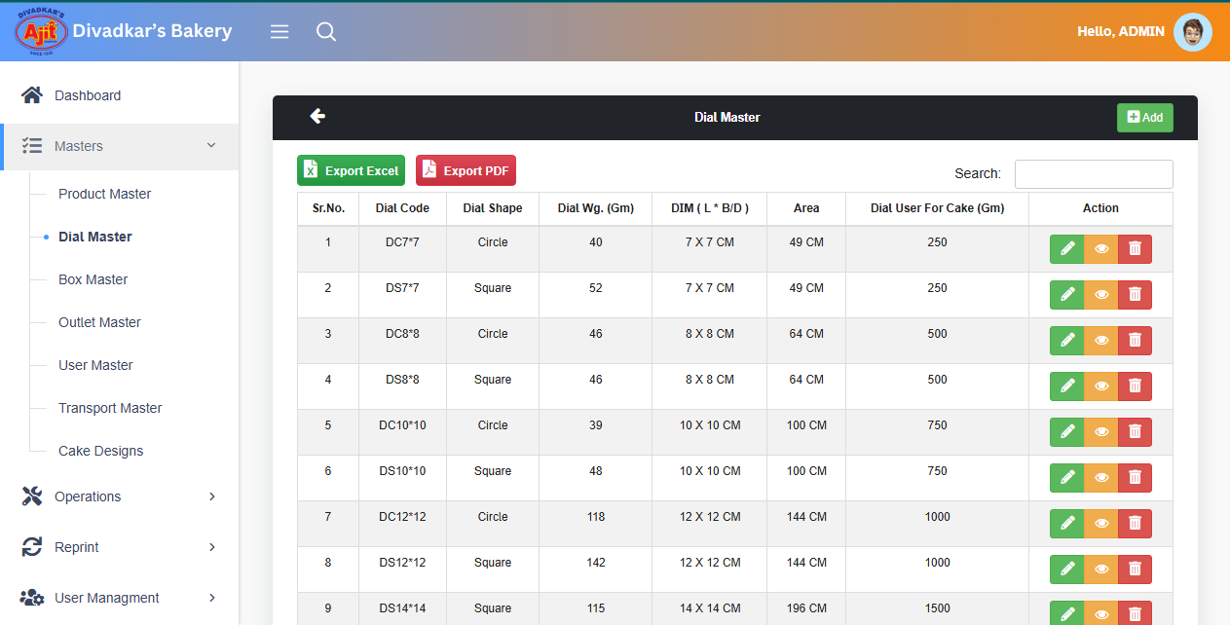

1. Select Dial Shape from the dropdown.
2. Enter Dial Weight.
3. Select Dial Uom as per Dial Weight.
4. Enter Dial Diameter.
5. Select Length Uom as per Dial Diameter.
6. Enter Cake Range for the enter Dial.

Click on Save option.

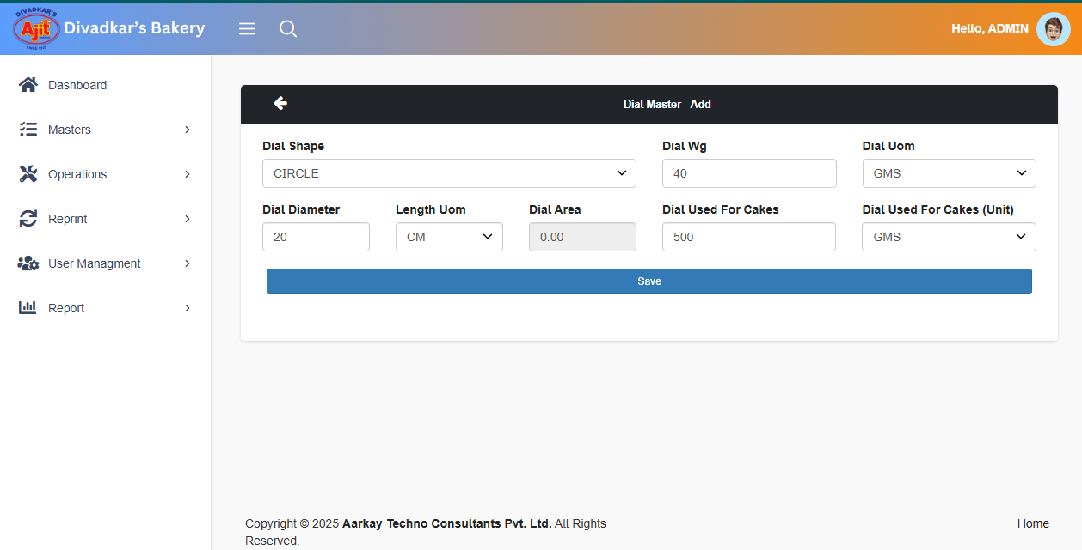

**2.** Click on Edit.

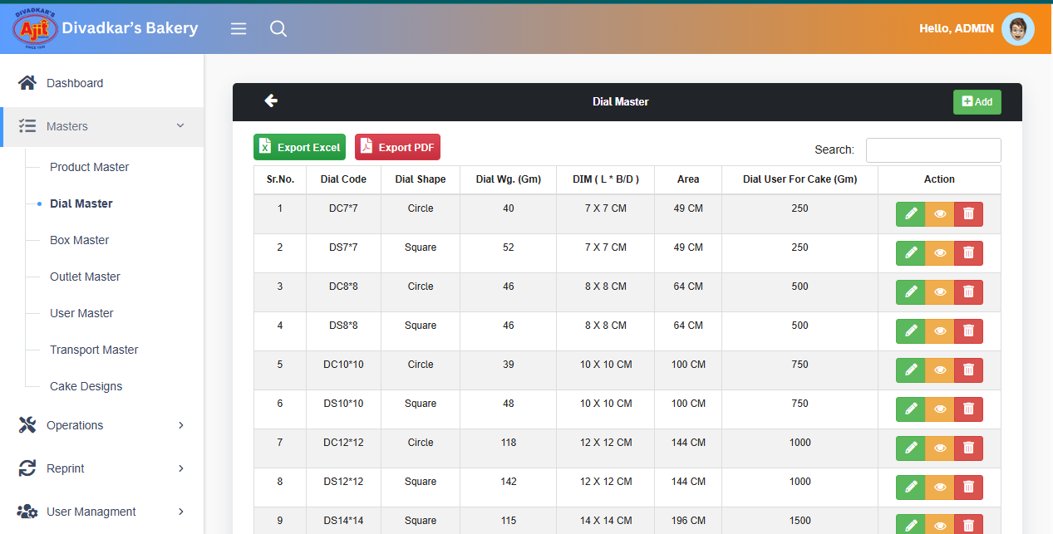

1. Select Dial Shape from the dropdown.
2. Enter Dial Weight as per Dial Uom.
3. Enter Dial Diameter as per Length Uom.
4. Enter Cake Range for the enter Dial.

Click on Edit.

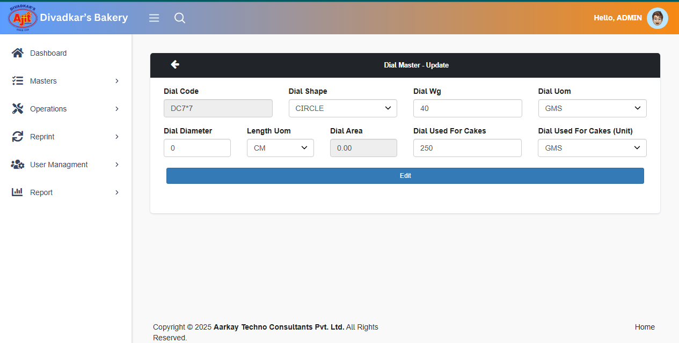

**3.** Delete.

If you click on Delete you get the message “**Are You Sure**” then click on “Yes, Delete it”.



**Step 4.** Click on **Box Master**.

1. Click on Add.

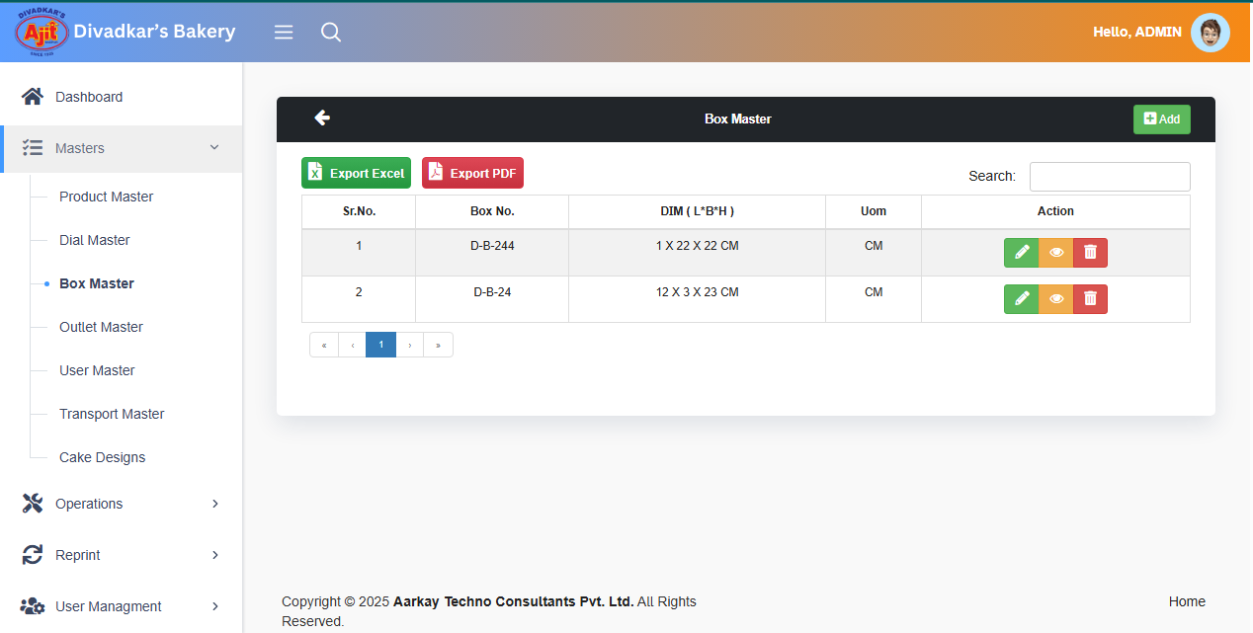

1. Enter Box No.
2. Enter Box Length as per UOM
3. Enter Box Breadth
4. Enter Box Height
5. Enter Box Area.

Click on Save.

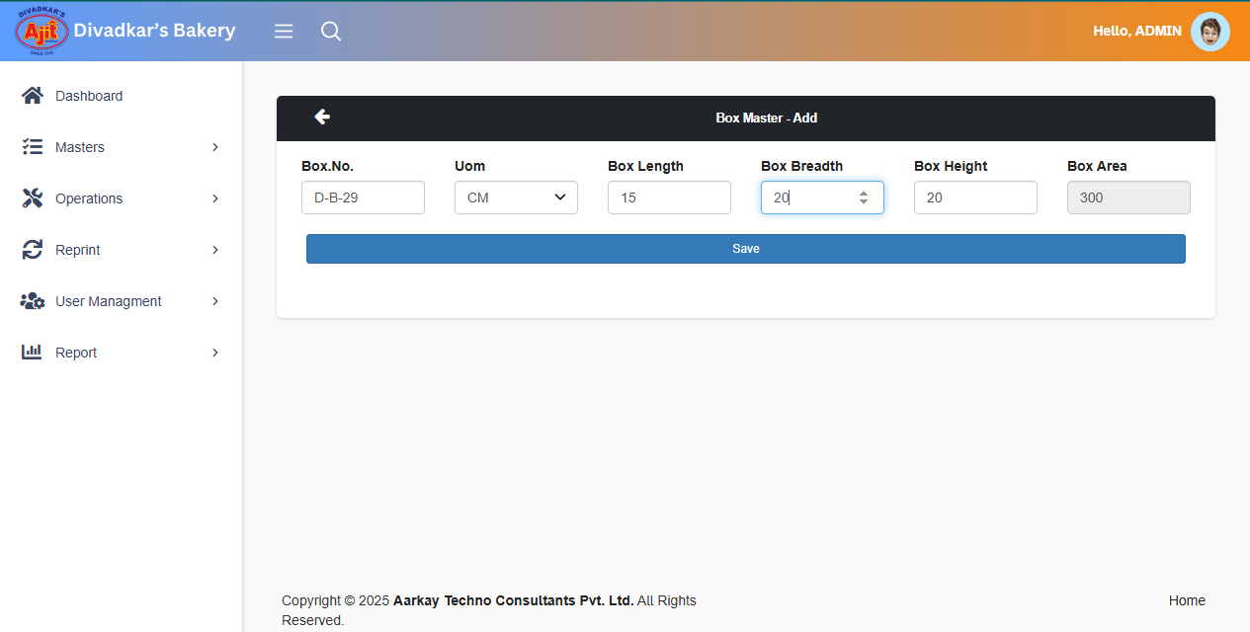

1. Click Edit for update Box Master.



1. Enter Box No.
2. Enter Box Length as per UOM
3. Enter Box Breadth
4. Enter Box Height
5. Enter Box Area.

Click on Edit.

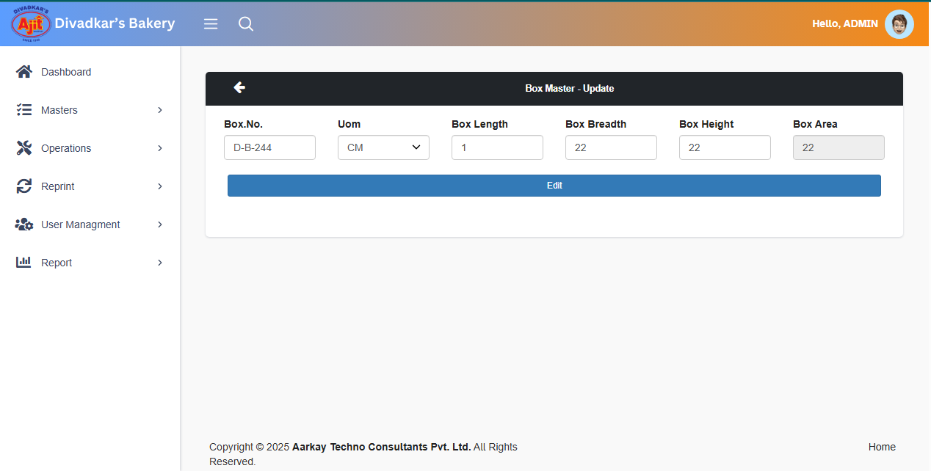

**3.** Delete.

If you click on Delete you get the message “**Are You Sure**” then click on “Yes, Delete it”.



**Step 5.** Click on **Outlet Master**.

**1.**Click on Add.

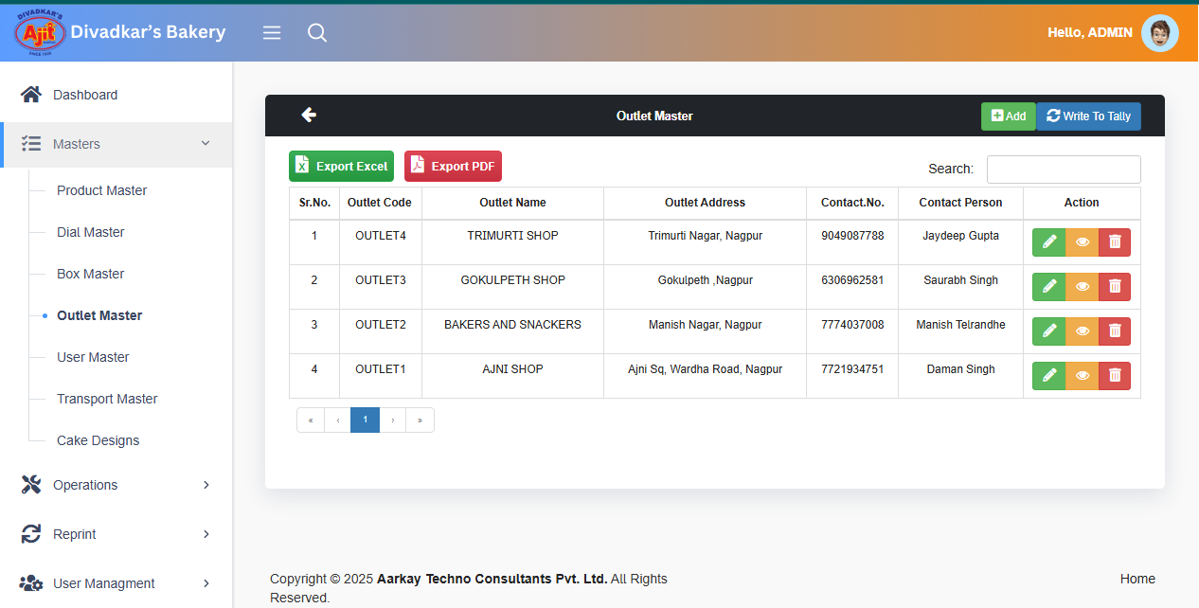

1. Enter Outlet Name.
2. Enter Name of Contact Person.
3. Enter Contact No.
4. Enter Address.

Click on Save.

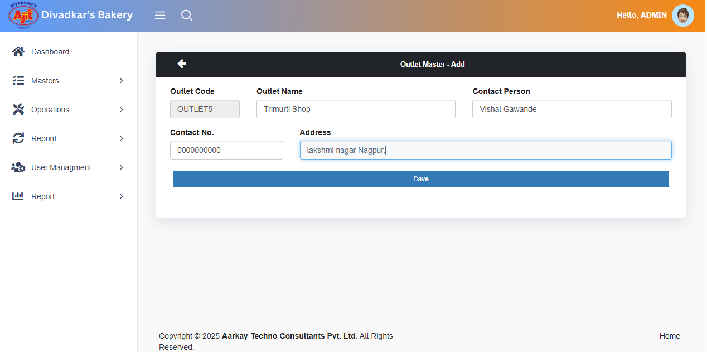

1. Click Edit for update Outlet Master.



1. Enter Outlet Name.
2. Enter Name of Contact Person.
3. Enter Contact No.
4. Enter Address.

Click on Edit.

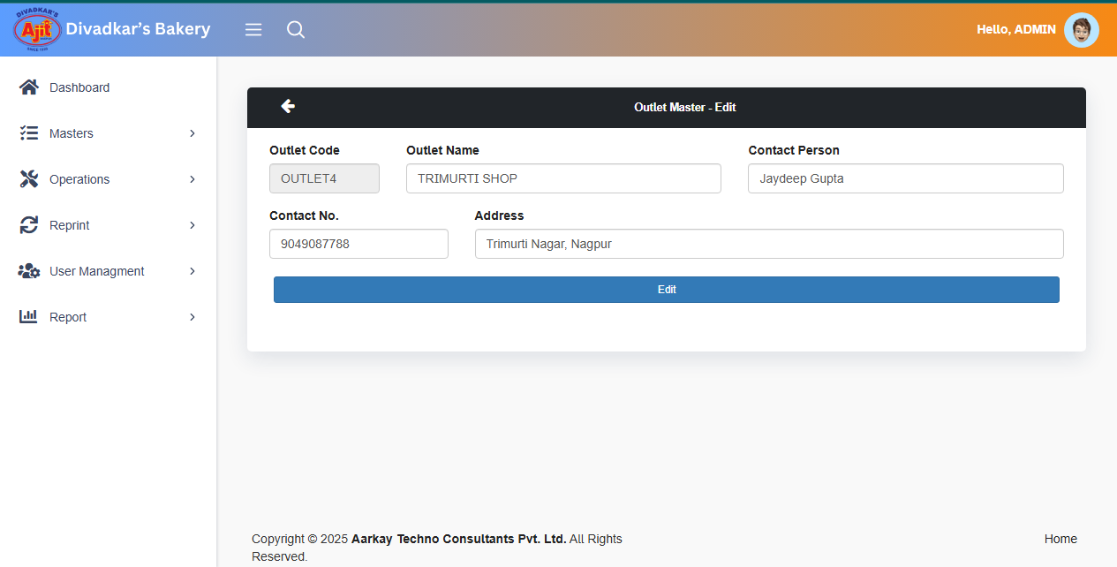

**3.** Delete.

If you click on Delete you get the message “**Are You Sure**” then click on “Yes, Delete it”.



**Step 6.** Click On **User Master**.

1. Click on Add.

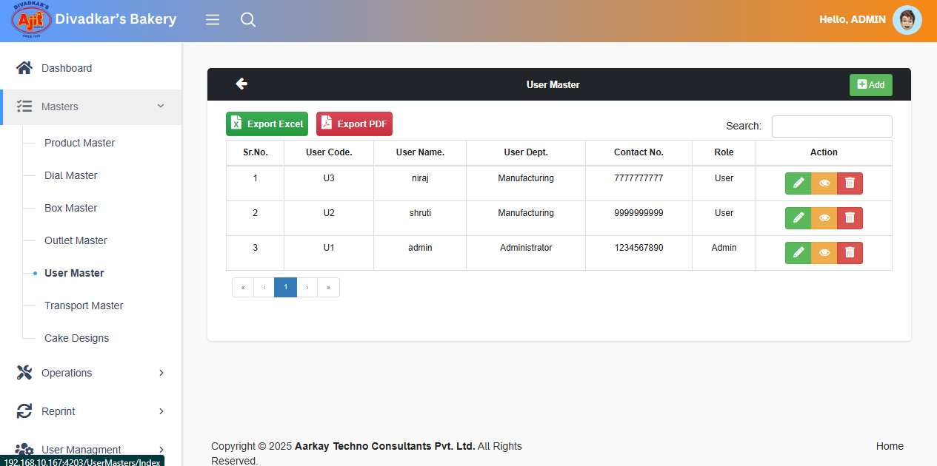

1. Enter User Name.
2. Enter Email.
3. Enter Password.
4. Select Department from the dropdown.
5. Enter Contact No.

Click on Save.

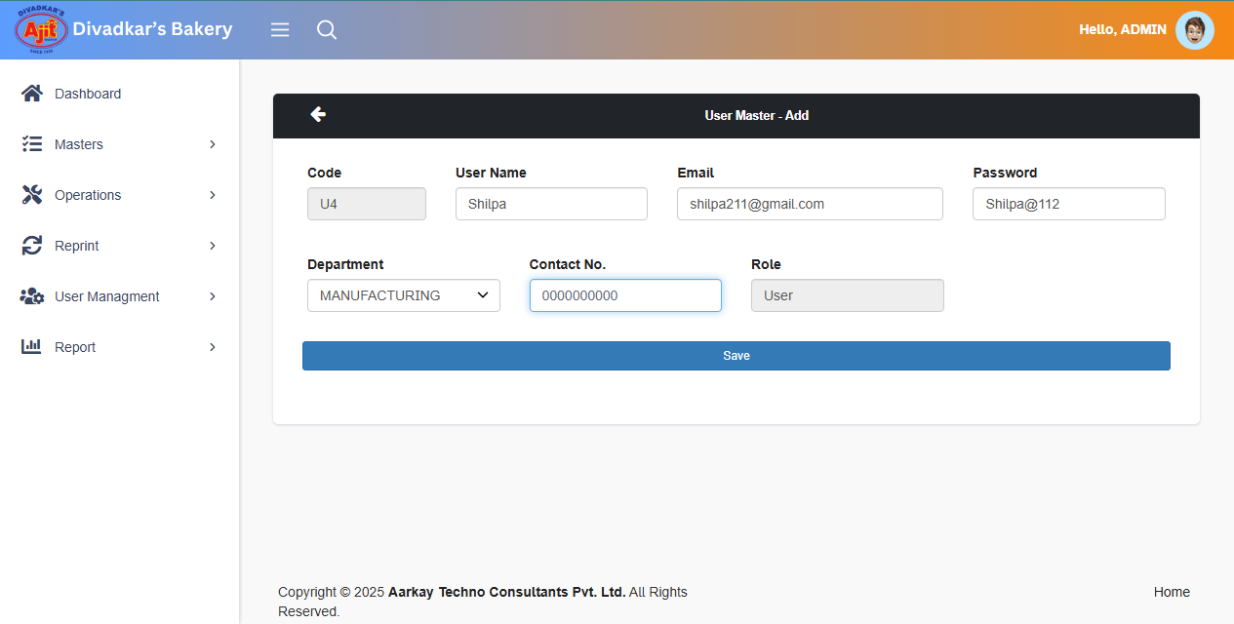

1. Click Edit for update User Master.



1. Enter User Name.
2. Enter Email.
3. Enter Password.
4. Select Department from the dropdown.
5. Enter Contact No.

Click on Save.

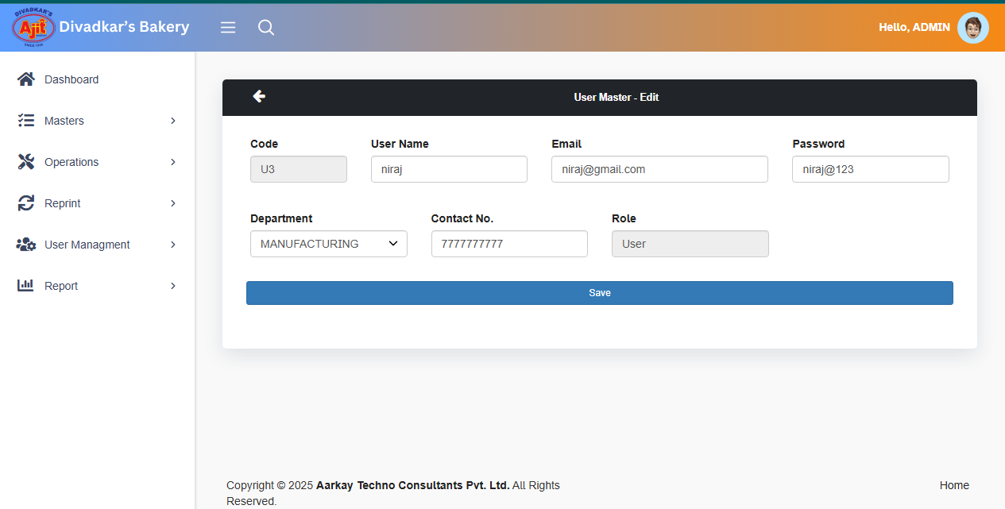

**3.** Delete.

If you click on Delete you get the message “**Are You Sure**” then click on “Yes, Delete it”.



**Step 7.** Click on **Transport Master**.

1. Click on Add.

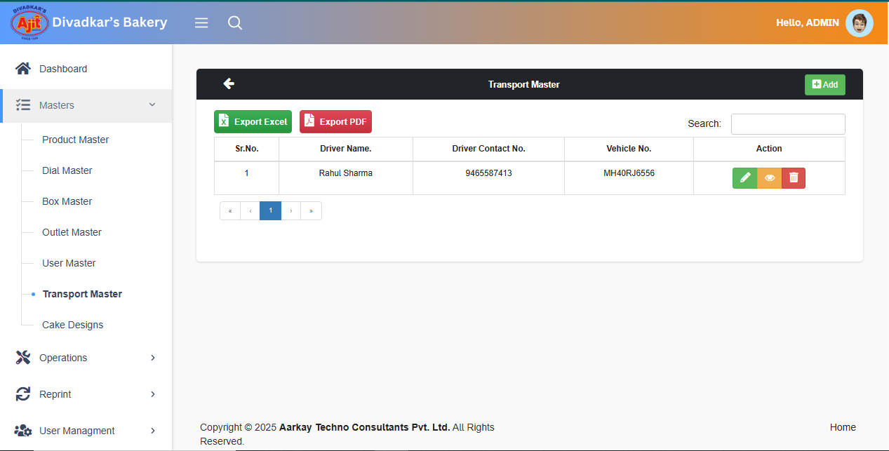

1. Enter Driver Name.
2. Enter Contact No.
3. Enter vehicle No.
4. Enter Vehicle Own from the dropdown.

Click on Save.

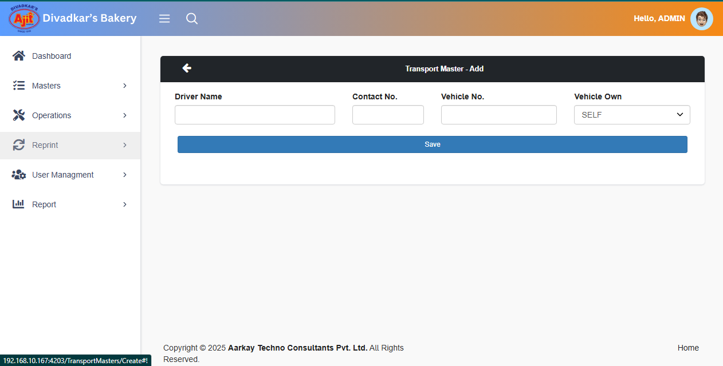

1. Click on Edit for Update Transport Master.



1. Enter Driver Name.
2. Enter Contact No.
3. Enter vehicle No.
4. Enter Vehicle Own from the dropdown.

Click on Edit.

.

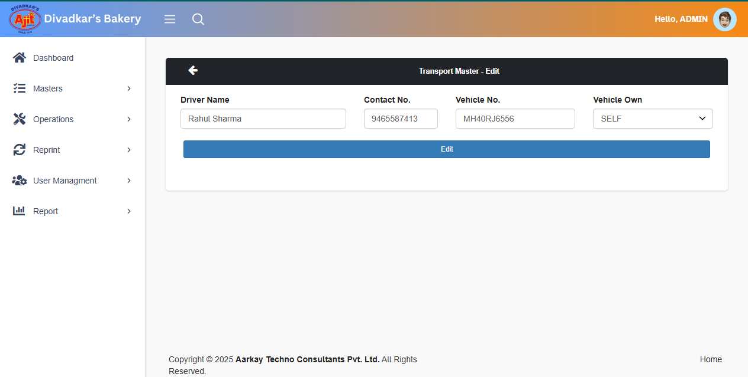

**3.** Delete.

If you click on Delete you get the message “**Are You Sure**” then click on “Yes, Delete it”.



**Step 8.** Click on **Cake Designs**.

1. Click on Add.

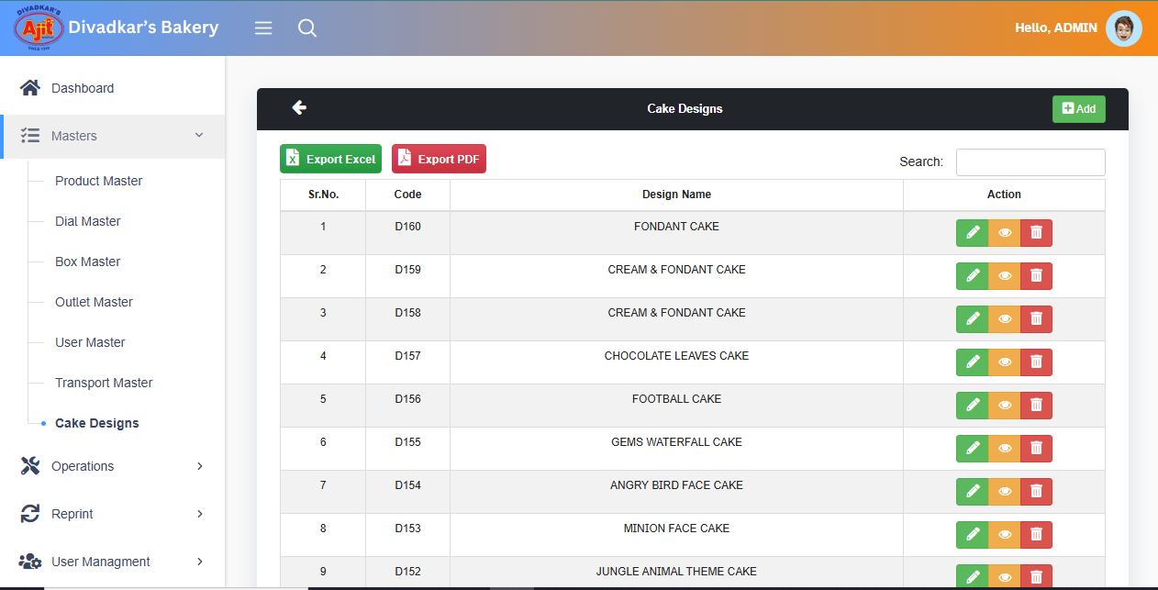

1. Enter Cake Design Name.

Click on Save.

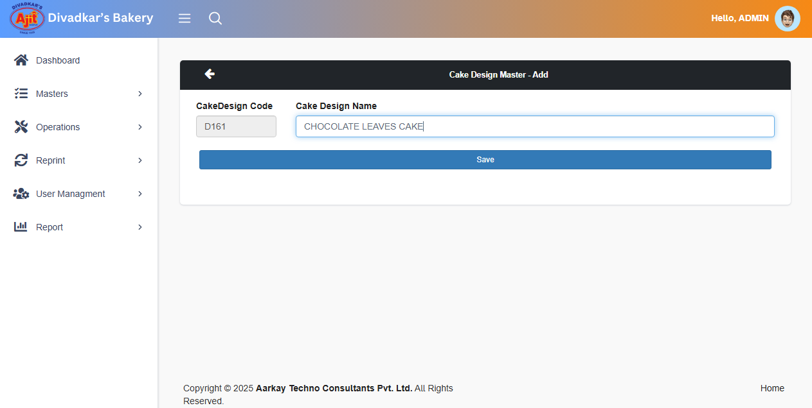

Click on Edit. 

1. Enter Cake Design Name.

Click on Save.

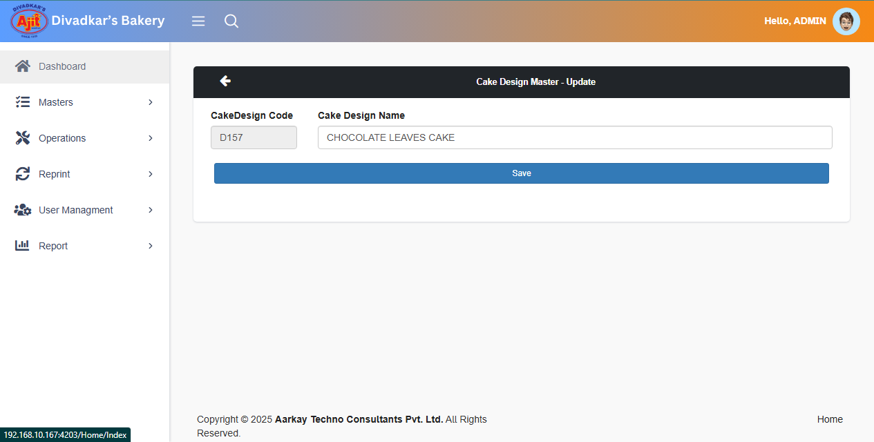

**3.** Delete.

If you click on Delete you get the message “**Are You Sure**” then click on “Yes, Delete it”.

